Dashboard Design
Date | 18 July 2026
Team ID | Sharmishtha Mishra
Project Name | HeartScope
Maximum Marks | 5 Marks

Activity 1: Interactive and Visually Appealing Dashboards

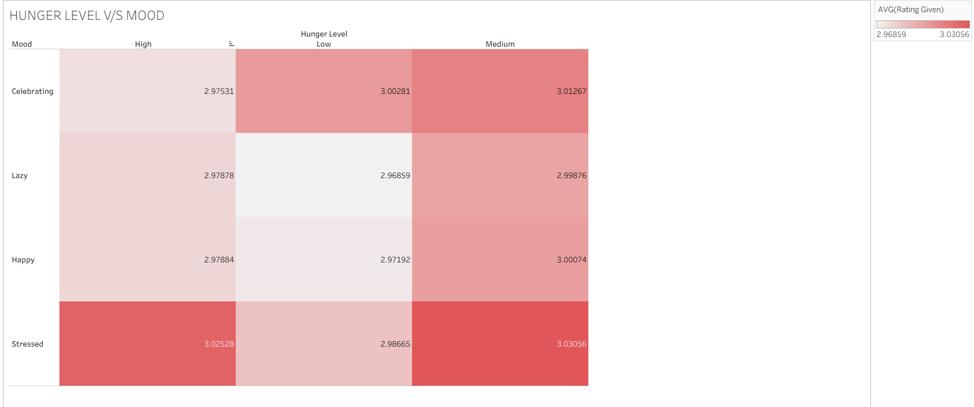
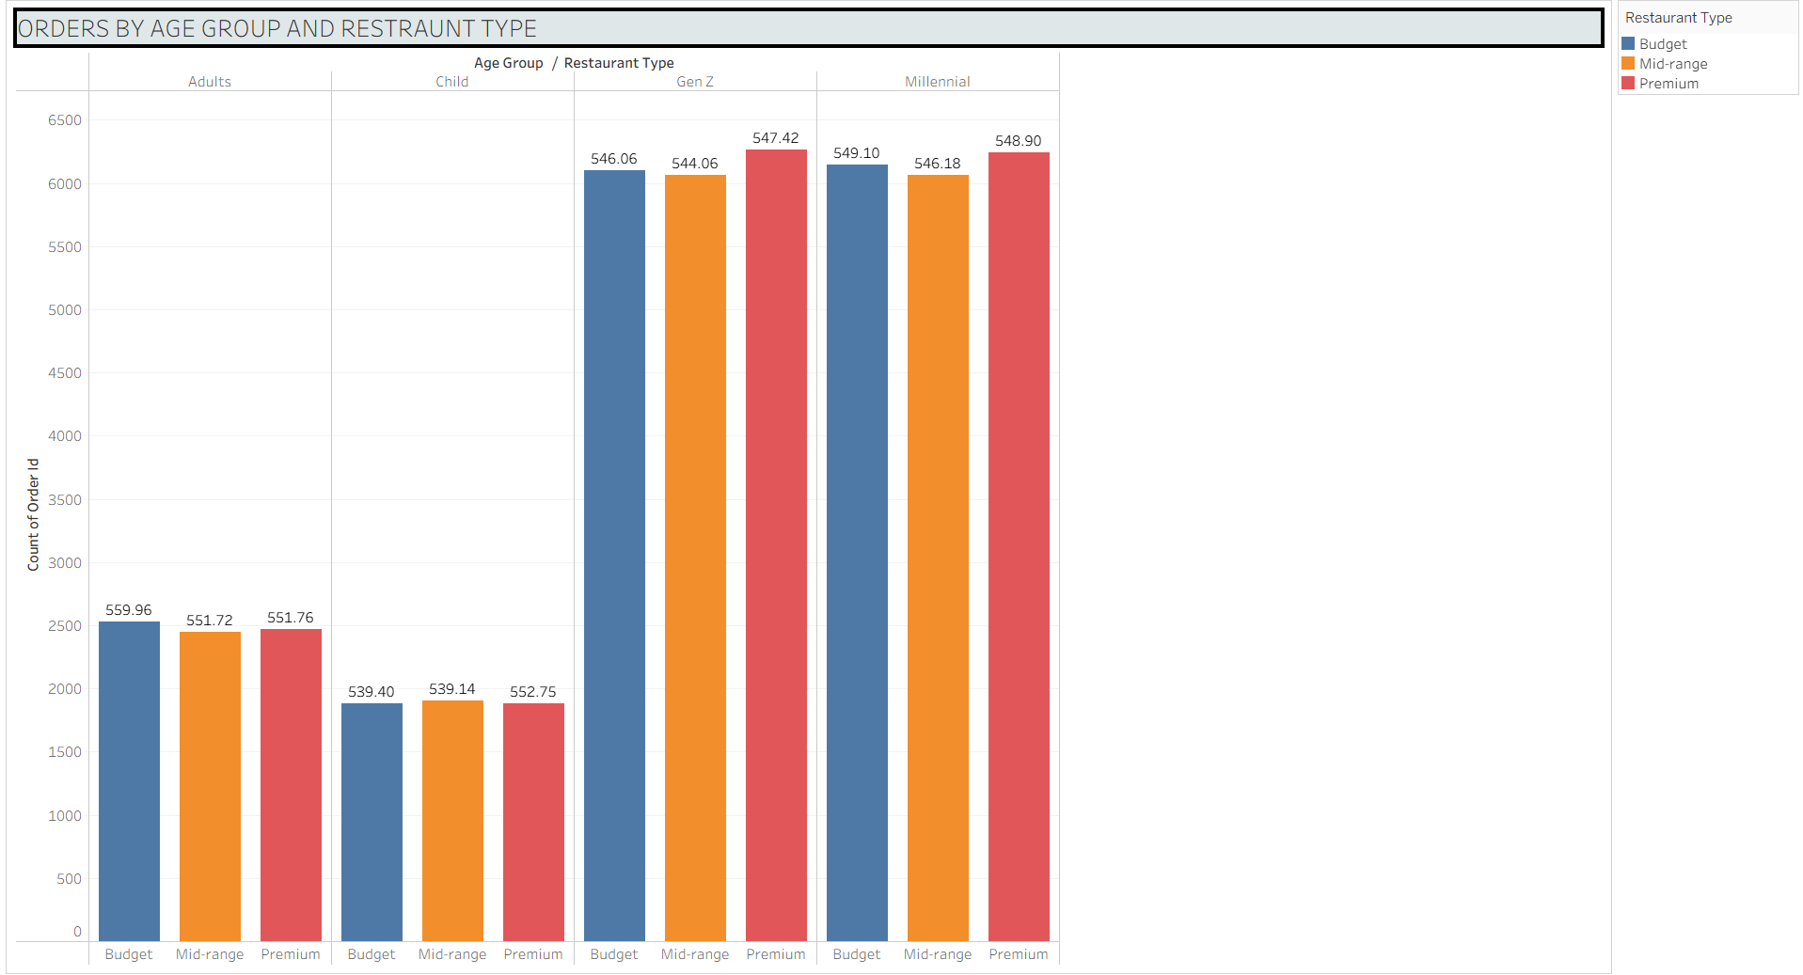

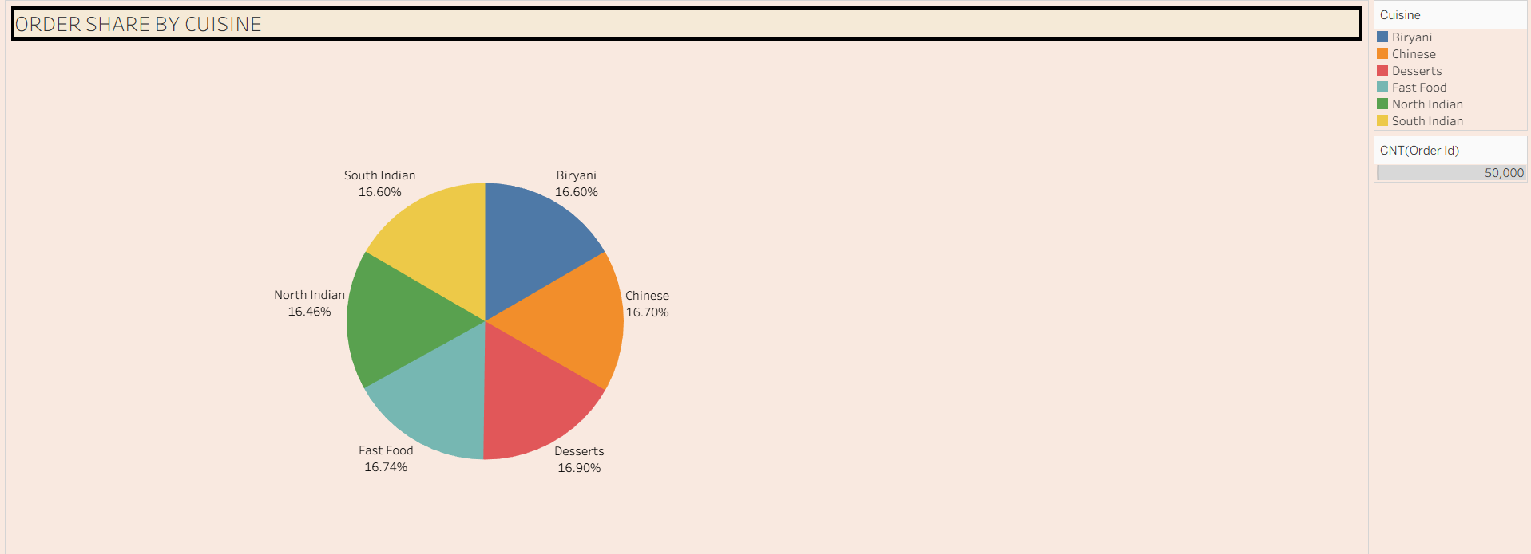
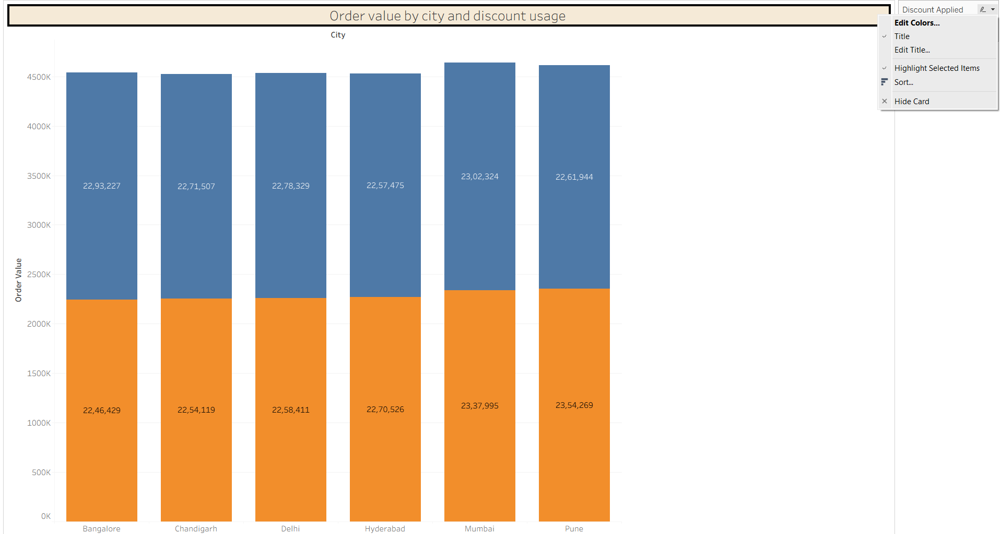
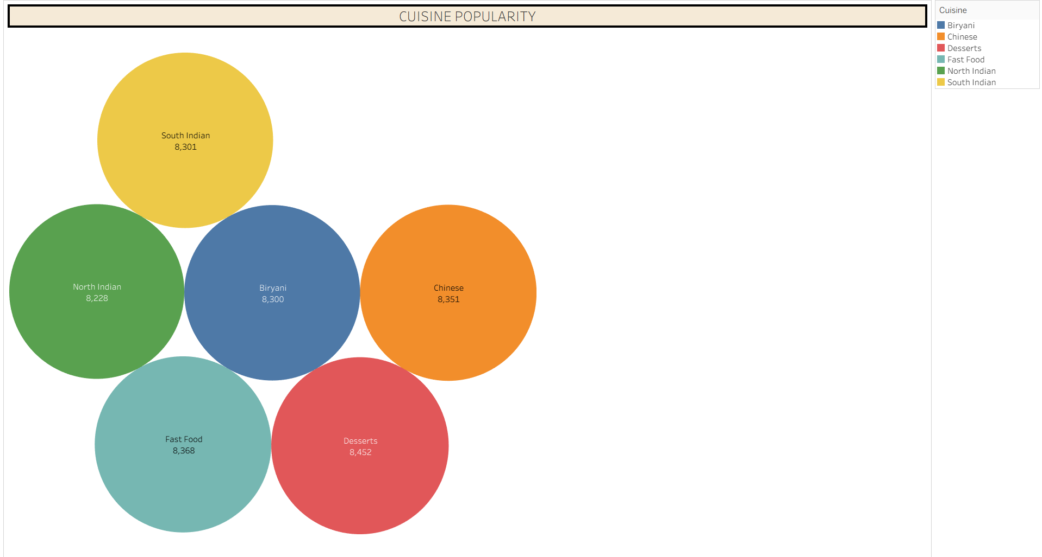

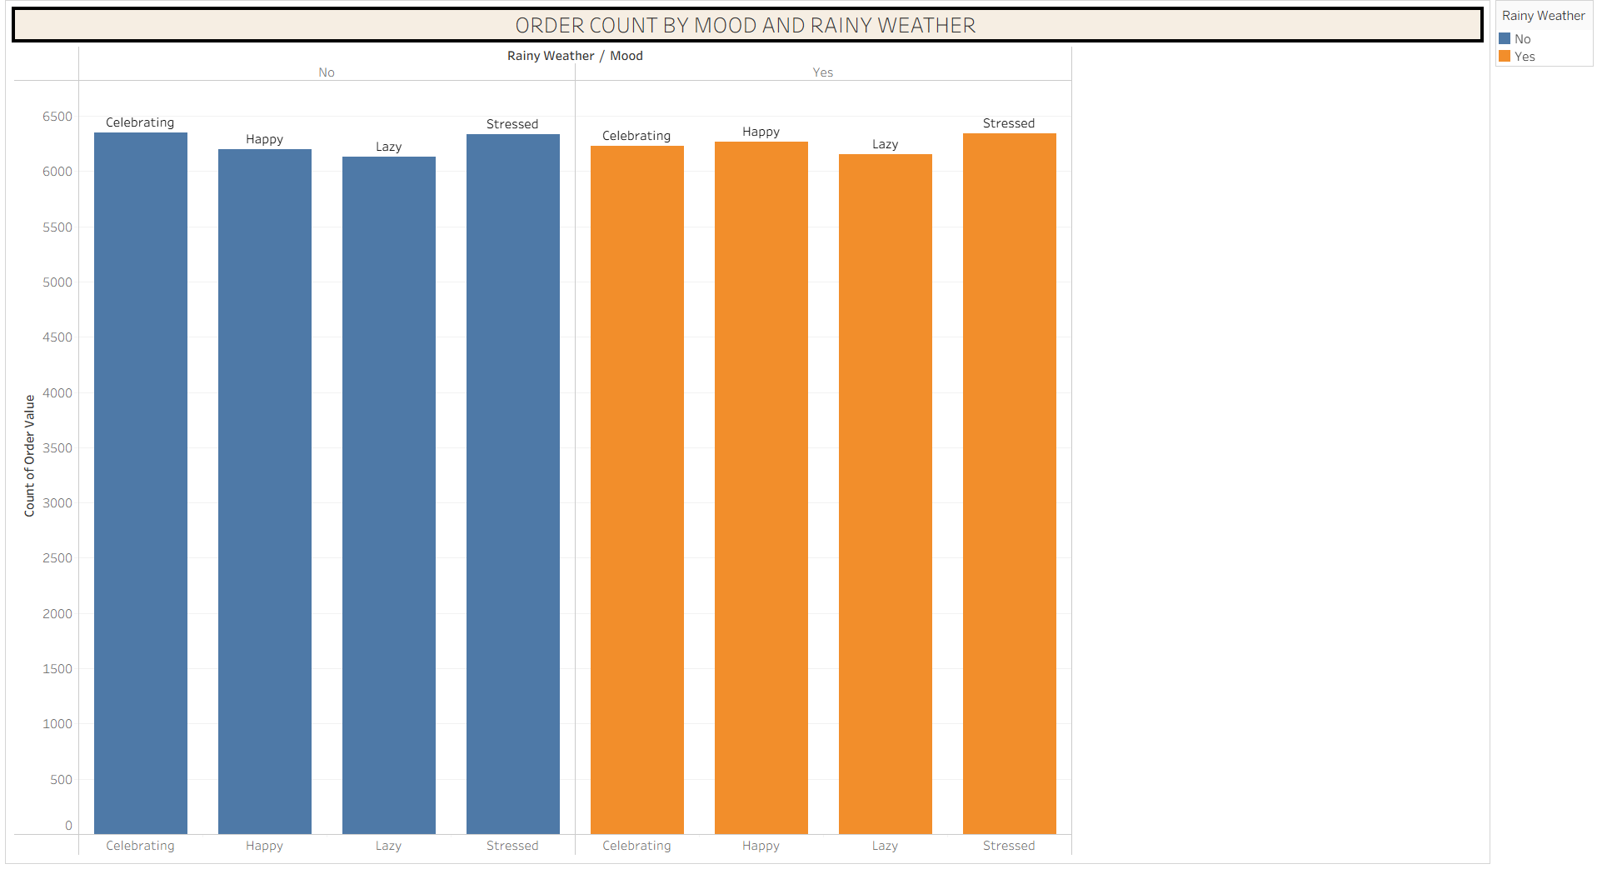
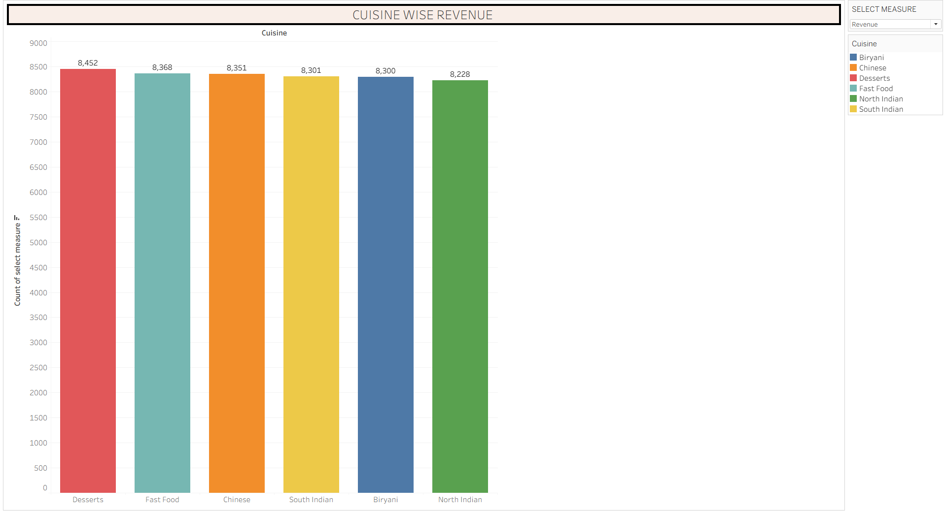
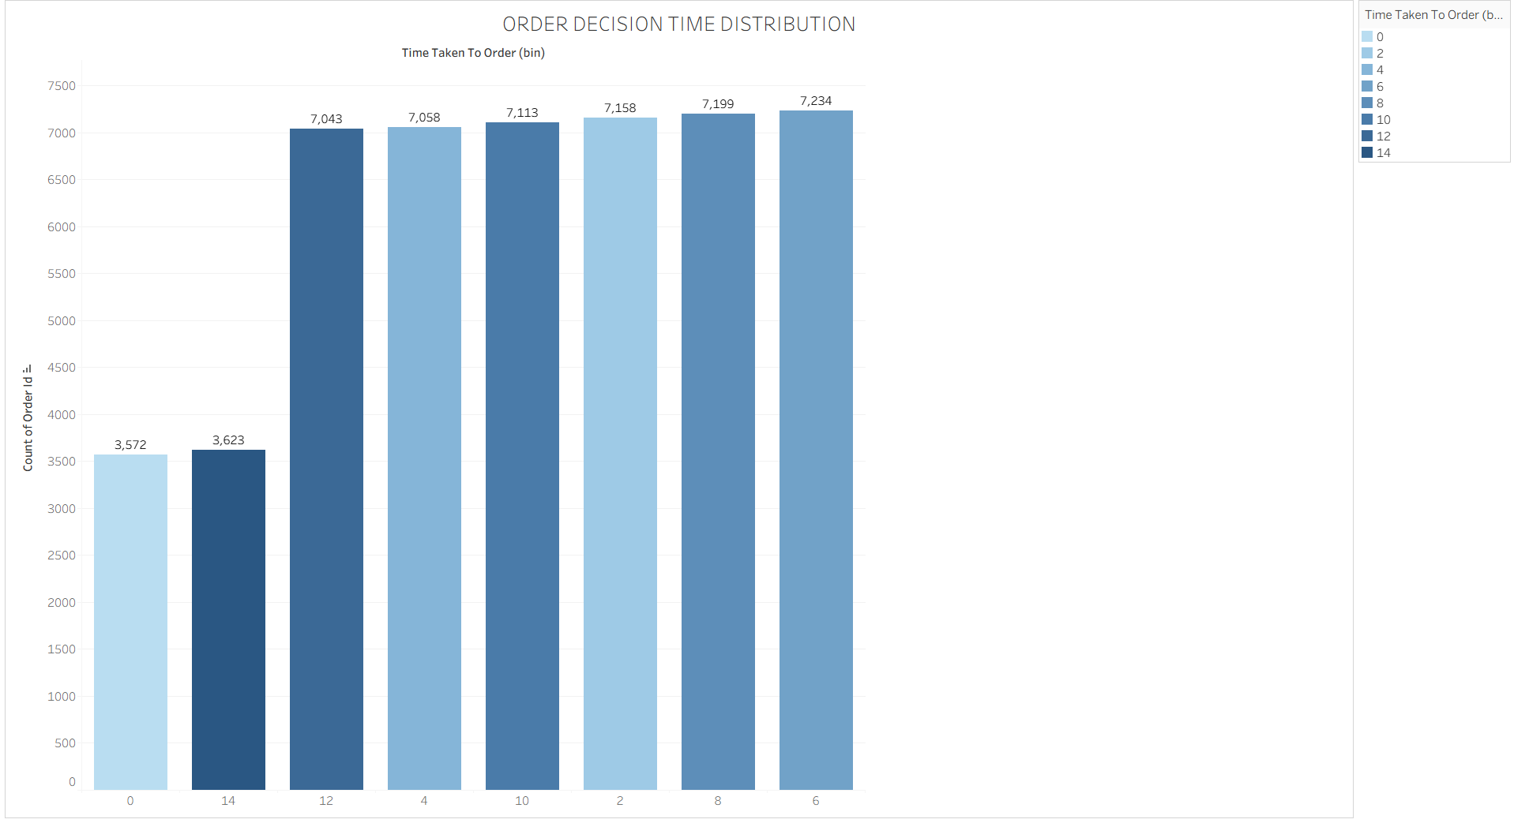

The core design principles—including a Clear and Intuitive Layout, Color and Theming, Interactive Filters, and Responsive Design—have been applied to create the HeartScope Food Delivery Consumer Behavior Analytics Dashboard. Below are the key outcomes and insights surfaced by the analytical interface:
- Executive Platform Scale (KPI Demonstration): The high-level KPI table aggregates core metrics—showcasing a total delivery fee earning of ₹2.98M, an aggregate order value of ₹27.39M, an average customer rating of 3, and a total order volume of 50,000. This gives stakeholders an immediate summary of overall marketplace scale and revenue generation.
- Demographic & Price Tier Preference (Orders by Age Group and Restaurant Type): The grouped bar graph breaks down order volumes across consumer age segments (Adults, Child, Gen Z, Millennial) and restaurant price tiers (Budget, Mid-range, Premium). It highlights that younger demographics like Gen Z and Millennials drive massive, consistent transaction volumes across all restaurant categories.
- Urban Revenue & Discount Impact (Order Value by City and Discount Usage): The stacked bar chart maps total order values across metropolitan markets (Bangalore, Chandigarh, Delhi, Hyderabad, Mumbai, Pune) segmented by discount application status. It demonstrates uniform regional spending distribution and provides clear visibility into how promotional discounts influence overall transaction value.
- Cuisine Popularity & Demand Share (Cuisine Popularity Bubble Chart): The packed bubble visualization illustrates the relative popularity and order distribution among major culinary categories (such as Desserts, Fast Food, Chinese, South Indian, Biryani, and North Indian), proving a balanced consumer appetite across menu types.
- Environmental & Psychological Drivers (Order Count by Mood and Rainy Weather): The comparative bar chart analyzes order frequencies under different weather conditions (Rainy vs. Non-Rainy) combined with consumer emotional states (Celebrating, Happy, Lazy, Stressed). This uncovers how environmental shifts and customer moods influence food delivery demand spikes.
- Dynamic Cross-Filtering & Custom Parameters: By implementing interactive filters and parameters for discount status, rainy weather, select measures, and time taken to order, business analysts can instantly slice the entire dashboard for targeted behavioral segmentation and operational optimization.

Activity 2: Live Deployment Link
Below is the verified public access link to the interactive, cloud-hosted visualization story:
Tableau Public Dashboard Link:
Tableau Dashboard Link

